**Variables in Azure DevOps Pipelines**

* Azure DevOps Pipeline has variables, we can assign values to be used within pipeline across stages, jobs or steps.
* Variables values can be changed during the pipeline execution
* Pipeline execution has 3 phases
  + Queue time phase
  + Compile phase
  + Runtime phase
* Variables can be used by 3 different expressions <https://learn.microsoft.com/en-us/azure/devops/pipelines/process/variables?view=azure-devops&tabs=yaml%2Cbatch#user-defined-variables>
  + macro $(var)
  + template ${{ variables.var }}
  + runtime expression $[variables.var]
* Syntax to be used in pipelines <https://learn.microsoft.com/en-us/azure/devops/pipelines/process/variables?view=azure-devops&tabs=yaml%2Cbatch#what-syntax-should-i-use>
* Script variables can be set from scripts "##vso[task.setvariable variable=myVar;]foo"
* Variables can be created at
  + pipeline level
  + stages level
  + jobs level
* Try this pipeline

---

trigger:

- main

pool:

vmImage: ubuntu-22.04

variables:

- name: var1

value: value1

stages:

- stage: stage1

displayName: 'Stage 1'

variables:

- name: var2

value: value2

jobs:

- job: job1

displayName: Job 1

variables:

- name: var3

value: value3

steps:

- bash: echo "##vso[task.setvariable variable=var1;]newvalue"

- script: "echo $(var1)"

- script: "echo $(var2)"

- script: "echo $(var3)"

* I have 10 variables and i want to use them in multiple pipelines these values can be secrets or text values, in these kind of cases we use variable groups. To create a variable group
* Lets create a variable group  
  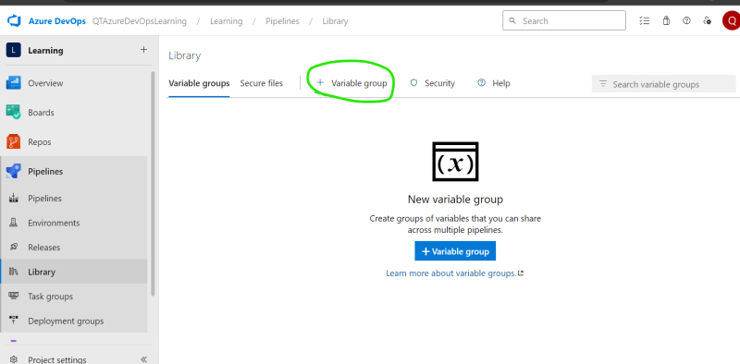  
  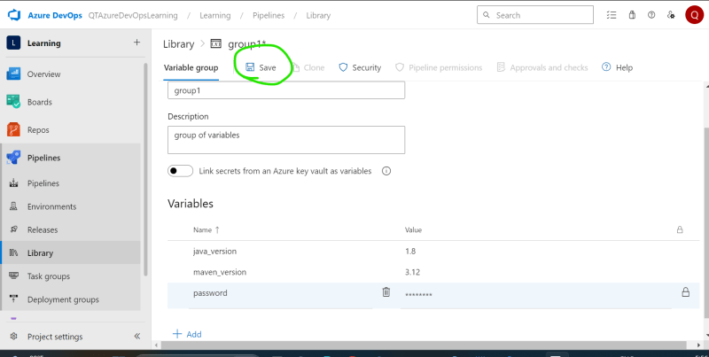
* Now look at below pipeline

---

trigger:

- main

pool:

vmImage: ubuntu-22.04

variables:

- name: var1

value: value1

- group: group1

stages:

- stage: stage1

displayName: 'Stage 1'

variables:

- name: var2

value: value2

jobs:

- job: job1

displayName: Job 1

variables:

- name: var3

value: value3

steps:

- bash: echo "##vso[task.setvariable variable=var1;]newvalue"

- script: "echo $(var1)"

- script: "echo $(var2)"

- script: "echo $(var3)"

- script: "echo java_version $(java_version) password = $(password)"

displayName: "Displaying values from group"

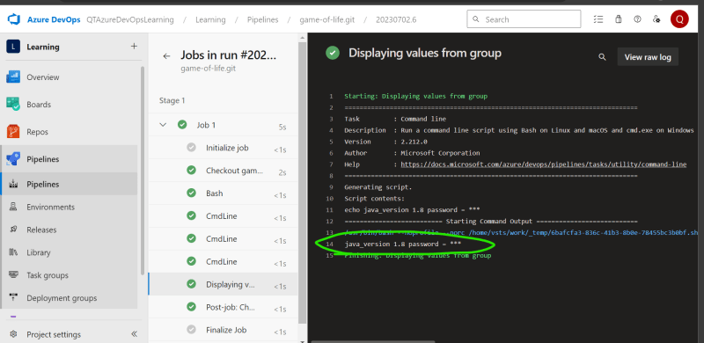

**Lets try writing a pipeline for the following**

* The application which we need to work
* manual steps

git clone https://github.com/DevProjectsForDevOps/StudentCoursesRestAPI.git

cd StudentCoursesRestAPI

docker image build -t shaikkhajaibrahim/studentcoursescd:(Build-ID) .

docker image push shaikkhajaibrahim/studentcoursescd:(Build-ID)

* Azure DevOps when it needs to connect to something external uses Service Connections.
* Lets create a service connection to docker hub

Navigate to Project Settings => Service Connections => New service connection and follow the screenshots below  
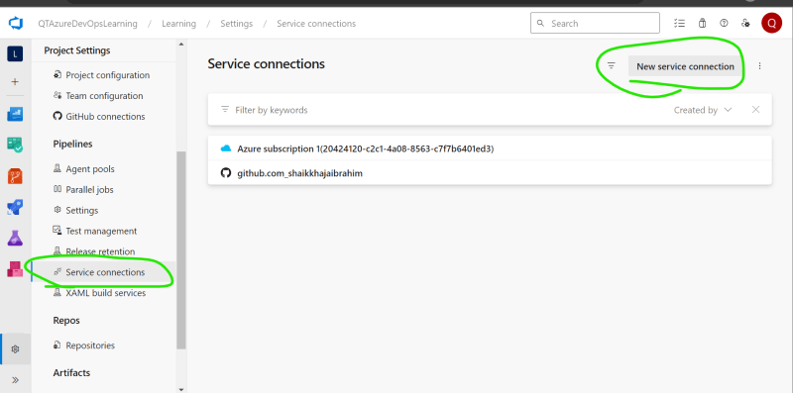  
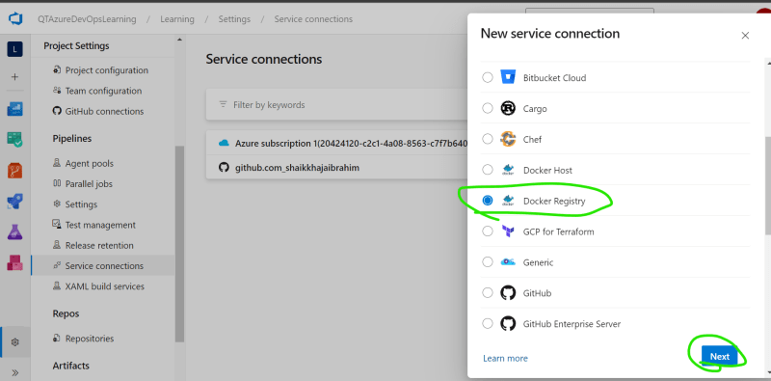  
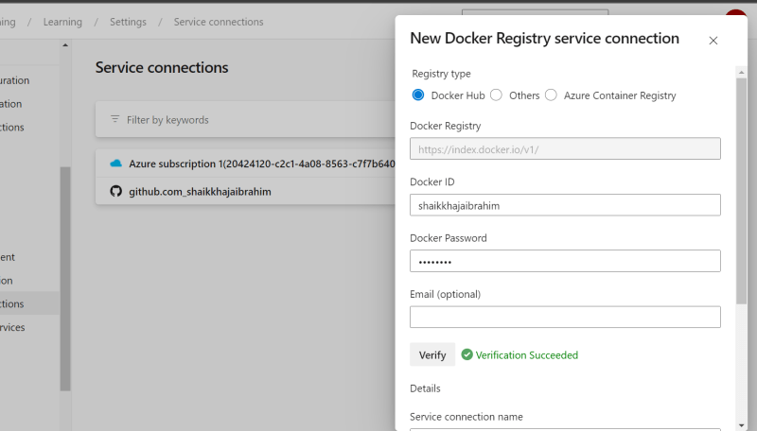  
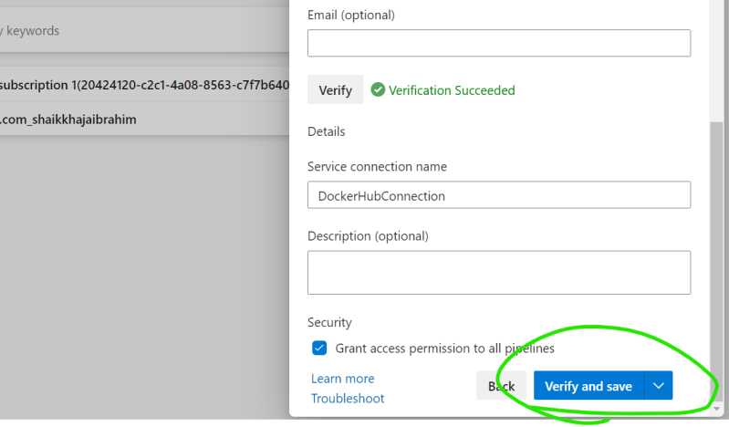

We have created a pipeline with following content

---

trigger:

- master

pool:

vmImage: ubuntu-22.04

steps:

- task: Docker@2

displayName: build and push docker image

inputs:

containerRegistry: 'DockerHubConnection'

command: buildAndPush

repository: 'shaikkhajaibrahim/studentcoursescd'

tags: '$(Build.BuildId)'

* Run the pipeline  
  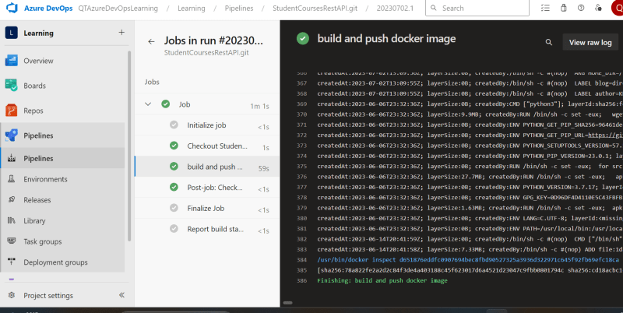  
  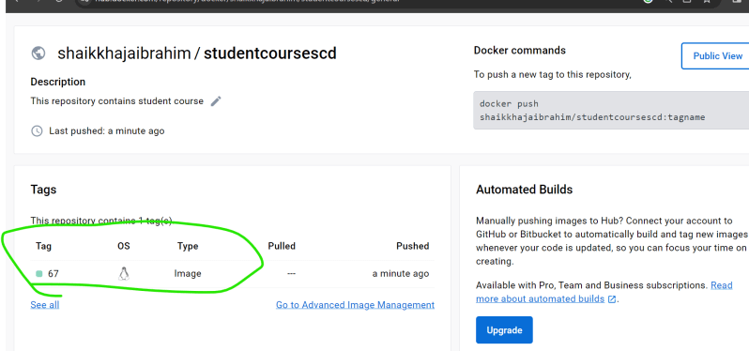

**Azure DevOps Extensions**

* Azure DevOPs Extensions provide extra set of tasks to Azure Pipelines. <https://marketplace.visualstudio.com/azuredevops/>
* <https://learn.microsoft.com/en-us/azure/devops/organizations/notifications/manage-team-group-global-organization-notifications?view=azure-devops> for notifications on teams channel
* Examples from Microsoft <https://learn.microsoft.com/en-us/azure/devops/pipelines/ecosystems/ecosystems?view=azure-devops>